

Exploring Consumer Awareness and Perception of Material Composition in Online Shopping

Presented to the Department of Software Technology
College of Computer Studies
De La Salle University - Manila
Term 3, A.Y. 2023-2024

In partial fulfillment of the course
STHCIUX - Human-Computer Interactions

MCO1: Needfinding Study (S13 - Group 5)

Submitted by:
Cabinbin, Pierre Genric N.
Dela Peña, Christian A.
Estañol, Miguel Francis M.
Garcia, Aurelio Rodolfo F.
Javid, Isaac D.
Jovellana, Reuben Seth G.
Sanchez, Chloe Jeanine E.

Submitted to:
Mr. Ryan Austin Fernandez

Submitted On:
June 25, 2024

Abstract
This needfinding study aims to explore the behaviors, preferences, and awareness of online shoppers regarding the material composition of products. The study primarily involved undergraduate students aged 18-26 years, utilizing data research, surveys, and interviews to gather comprehensive data. Key findings indicate that while most respondents shop online monthly using mobile devices, there is a notable dissonance between what they first notice about a product (primarily price) and what they consider most important when making purchasing decisions (product ratings and reviews). Interviews revealed varying degrees of importance placed on material composition, with some emphasizing quality and eco-friendliness, while others prioritize cost. The study identified three distinct user personas, each with unique shopping habits and expectations. The insights gathered highlight the need for more informative online shopping experiences, addressing the United Nations Sustainable Development Goal of Responsible Consumption and Production. The research also focuses on enhancing accessibility to detailed product information to aid consumers in making more informed and sustainable choices.

Introduction
Online shoppers often encounter problems like lack of transparency about the material components of the products they purchase in various online platforms. Lacking information towards the products bought can lead to uninformed decisions and irresponsible consumption habits. This needfinding study aims to explore an online consumer's behavior and perspective and what challenges they will face due to this information and awareness gap regarding material composition. By understanding their habits and experiences while faced with insufficient material information about the products they buy, the researchers will provide insights on the importance of responsible consumption and production addressing the researcher’s chosen Sustainable Development Goal of the United Nations: Responsible Consumption and Production. Therefore, in this needfinding study, the researchers will focus on the initial problem statement: How might we make informative online shopping more accessible for online shoppers?

Research Questions
To gain a better understanding of the awareness and behaviors of online shoppers regarding the material components of products, this study will aim to address the following research questions.

- What are common toxic materials used in producing products? How common are they?
- On which medium do online shoppers shop more often (mobile, PC, tablet, etc.)
- Why or why don’t online shoppers pay attention to the material components of products they buy online?
- What is the first thing users notice when they open a product’s details on an online shopping site?
- What are the harmful side effects among users when they use products that are dangerous?
- How aware are users of the toxic materials found in products commonly sold in e-commerce services?

METHODOLOGY
Study Participants
The study participants for this needfinding study were selected through convenience sampling, primarily consisting of undergraduate students enrolled in DLSU, aged 20 to 22 years. Additional respondents ranged from 18 to 26 years old.
General Methodology
To supplement information and comprehensively address our research questions, the researchers employed three methods: Data Research, Surveys, and Interviews.
Data research was conducted to understand the scope of various toxic chemicals, their adverse reactions, and common products sold. Surveys and Interviews were utilized to gain insights into respondents’ awareness, shopping behaviors, and considerations when purchasing products online.

The researchers conducted seven individual interviews using online teleconferencing apps such as Zoom and through in-person meetings. The interviews are then recorded into text transcripts. Before conducting the interviews. Consent was obtained from the participants, ensuring they were informed of the study’s purpose and their involvement. The following questions were asked in chronological order during the interviews:

- Can you estimate how many days a week you shop online? Why do you shop that often?
- When do you usually shop online? Often? or only during paydays, or during sales, etc.?
- How often do you buy products on e-commerce services and online stores? Are there specific reasons why you behave that way?
- On which devices do you shop online? Why do you choose that medium?
- Have you or anyone you know had a toxic or harmful reaction/s or side effect/s to a specific product you bought online? Can you share more about that experience?
- When you shop online, what is the first thing you notice about a product you want to buy? Price, Rating, Image, Seller/Store, Number of products sold, Discounts, Other? Why that feature?
- How important do you consider the material composition of the products you purchase online? Why do you give it that level of importance?
- How important do you think other people view the material components of the products they buy online?
- What shopping application/s do you use? What do you see in them?

For surveys, similar questions were asked in a quantitative light, in line with the research questions. The researchers employed Likert Scales (ranging from 0 to 5), dichotomous survey scales (Yes or No questions), and multiple-choice questions. The survey collected demographic information, including age, name, and gender. Similar to the interviews, consent was also asked before proceeding to the survey proper. The questions asked were:

- How often do you buy products on e-commerce services and online stores? (Range: 0 - 5)
- How often do you consider the material composition of the products you purchase online? (Range: 0 - 5 )
- Can you estimate how many days a week you shop online?
- On which devices do you shop online? (Tickbox: Mobile Phone, Tablet, PC, Telephone?)
- Rate yourself on how frequently you pay attention to the material components or specifications of the products you buy online. (Range: 0 - 5)
- Have you ever experienced any harmful side-effects to specific materials? (Yes or No)
- Have you ever had a toxic reaction to a specific material found in a product you bought online? (Yes or No)
- Do you know anyone who had a toxic reaction to a specific material found in a product that a person bought online? (Range: 0 - 5 )
- When you shop online, what is the first thing you notice about a product you want to buy? (Select: Price, Rating, Image, Seller/Store, Number of products sold, Discounts, Other)
- What type of products do you usually buy online? (Tickbox: Clothing, Electronics, Household items, Personal care, Others)

Through these methods, the researchers aimed to gather a comprehensive understanding of online shopping behaviors and the perceived importance of material composition in consumer decisions.

ANALYSIS OF RESULTS
Data Research Results
The New York Health Foundation released a document containing materials found in common self-care products used in the everyday lives of quite possibly billions of people on the planet. These materials have significant evidence regarding their potential to cause harm to the human body^{[1]}.
Toxin | Product with Toxin | Description
Butylated Hydroxyanisole (BHA) | Makeup | BHA is classified by the National Toxicology program as being “reasonably assumed to be a human carcinogen”. Causes stomach cancer in rats, mice, and hamsters as well as liver cancer in fish.
Formaldehyde | Salon hair-straightening products and nail hardeners | Classified as “known to be a human carcinogen” by the National Toxicology program. Occupational exposure, typically respiratory, has been scientifically linked to nasopharyngeal cancer, sinonasal cancer, and lymphohematopoietic cancer, specifically myeloid leukemia.
1,4-Dioxane | Foaming products (shampoo, body wash), lotions | In lab animals, high levels of 1,4-dioxane exposure has led to various complications, including liver and kidney damage.
Parabens | Makeup, moisturizers, hair care products, and shaving products | Possible endocrine disruptors. Potential immune or allergenic effects. Increases migratory and invasive activity of human breast cancer cells in vitro. Correlated with sperm DNA damage and poor reproductive health in males.
Phthalates | Perfumes, hair sprays, soap, shampoo, nail polish, and skin moisturizers | Certain phthalates in pregnant women have been correlated to reproductive maldevelopment of male fetuses and children’s ADHD. For men, correlated sperm DNA damage
Toluene | Nail polish, salon hair treatments | Toluene exposure can cause cognitive and behavioral changes in mice. Humans exposed to high levels can show central nervous system depression, neurobehavioral impairment, and upper respiratory tract irritation. With massive exposure, accumulation of fluid in the lungs and respiratory arrest may ensue
Triclosan | Toothpaste | Correlated with hay fever and allergies in children. Suppresses thyroid hormones in lab rats
Sodium Laurethsulfate (SLS) | Toothpaste, soap, shampoos, bath products, and moisturizers | Lengthen duration and increase pain in patients with specific kinds of ulcers. Considered an eye, skin, and lung irritant

Additionally, several medical and environmental organizations have raised concerns regarding the prevalence of microplastics found in both the environment and the human body. Microplastics are microscopic plastic waste resulting from both producing products and the gradual breakdown of existing plastic products^{[2]}. Microplastics have been detected by various agencies all over the world, particularly in the atmosphere which humans breathe^{[3]} and inside the creatures of the ocean^{[4]}, which humans consume. Due to both, humans have been found to have plastics inside their own bodies^{[5]}. Anatomical areas afflicted with microplastics include the lungs, the blood vessels, and even male semen^{[6]}. According to Plastic Oceans, an organization dedicated to resolving and raising awareness about plastics in ocean environments, the following plastics are considered the most commonly used in everyday life^{[7]}:
Plastic | Products
Polyethylene Terephthalate (PET or PETE) | Beverage bottles, Food bottles/jars (salad dressing, peanut butter, honey, etc.) and polyester clothing or rope
High-Density Polyethylene (HDPE) | Milk cartons, detergent bottles, cereal box liners, toys, buckets, park benches and rigid pipes.
Polyvinyl Chloride (PVC or Vinyl) | Plumbing pipes, credit cards, human and pet toys, rain gutters, teething rings, IV fluid bags and medical tubing and oxygen masks.
Low-Density Polyethylene (LDPE) | Low-Density Polyethylene (LDPE)
Polypropylene (PP) | Straws, bottle caps, prescription bottles, hot food containers, packaging tape, disposable diapers and DVD/CD boxes (remember those!)
Polystyrene (PS or Styrofoam) | Cups, takeout food containers, shipping and product packaging, egg cartons, cutlery and building insulation
Other plastics | Eyeglasses, baby and sports bottles, electronics, CD/DVDs, lighting fixtures and clear plastic cutlery

Interviews
Interviews were conducted with respondents on their shopping habits, the importance of material composition, and their overall experience with e-commerce platforms. While the researchers have gathered information such as the respondents’ names and specific occupations, this information has been redacted within this needfinding study for privacy considerations. Respondents are instead indicated by the pseudonym “Respondent #” (e.g. Respondent 1).

Shopping Frequency and Behavior
Most respondents reported shopping for necessities, with varying frequencies. Respondents 1, 3, 4, and 7 indicated they are occasional buyers, shopping either monthly or during sales. Respondent 1 mentioned

“Hmmm siguro if estimate ko a week siguro … Parang ano lang siguro almost once or twice lang every 3 months ganoon. Kasi usually naman wala naman ako masyadong ano eh kailangan na bilhin”

Respondent 6 shared the same sentiment, shopping once or twice a month, usually during paydays and sales, and using vouchers to lessen the price.

Respondents 2 and 5 shop more frequently. Respondent 2 noted shopping every Friday or Saturday to restock groceries, and for their internship, where they shop six times a week to find potential suppliers. Respondent 5 does window shopping often and buys products at a cheaper price.

Preferred Shopping Application/s
Respondents preferred using well-known platforms for their online shopping. Respondents 1,4 and 6 favored Shopee and Lazada due to their credibility and popularity. Respondent 4, an avid collector of figurines and other related merchandise stated:

“Yeah I mainly use Lazada and I usually look there. And then there was some occasional parang browsing stuff where I look for ano, figurines, specifically yung nendoroids. So
yeah there’s that. Pero I guess there’s some things I buy where it’s usually just parang
miscellaneous lang like you know, pins or something, ganon.”

Respondent 2 exclusively used Amazon, emphasizing its credibility and popularity. Respondents 5 and 7 had different preferences; Respondent 5 used Lazada and Zalora for their variety, and Respondent 7 preferred TikTok Shop for its new and good quality products, stating,

“Tiktok shop mas maraming bagong entrepreneur like bagong brand na hindi pa nakikilala pero maganda pala quality.”

Device Preference/s
The majority of respondents preferred using smartphones for online shopping due to their convenience and accessibility. Respondents 1, 3, 4, 5, 6, and 7 all cited convenience as a key reason. In addition to the perceived convenience of smartphones, respondent 5 stated

“I use my mobile phone since the app offers more vouchers that allow you to buy for cheaper”

Respondent 2, however, used their intern or company desktop, highlighting the convenience of opening multiple tabs given the device’s hardware specifications when compared to smartphones.

“What I mostly like about it is the RAM. I need detailing to what should be ordered. In this
case I won't have problems for multiple tabs.”

First Noticeable Element When Buying from Online Stores
Respondents noticed different elements first when shopping online. Price was a common initial consideration for Respondents 2, 5, and 6. Respondent 5 noted

“Price, online shopping or any form of shopping is always affected by price. A quality product
with a good price is always the standard”

Respondents 1 and 3 look at images and the number of sales for a specific listing, respectively. Respondent 4 focused on ratings, while Respondent 7 considered the brand.

“Brand, para mas malaman ko kung legit ba or okay yung quality niya.”

Importance of Material Composition
The importance placed on material composition varied among respondents. Respondent 1 considered it very important, viewing it as an indicator of quality and ranking it among the top considerations when buying a product.

“hmmm Material Composition… I think important naman talaga yun eh kase kung baga dun nagbabase yung quality ng product na bibilhin mo… Sabihin natin keyboard tas yung- kung ikocompare mo yung keyboard gawa siya sa ano full on plastic lahat tas compare mo siya sa mech keyboard na kunyari may aluminum based tas parang yung material hindi lang plastic ganon edi syempre sobrang importante non… Top 2 or Top 3 siya hindi siya yung pinaka-importante just because kasi kailangan parin itake into account yung ano yung budget mo.”

Respondent 2 emphasized the eco-friendliness of products, especially from an intern’s perspective, while Respondent 4 gave quality and material finish more thought due to their expensive hobby, noting the possibility of dangerous materials. Respondent 3 places low importance on material composition personally but recognizes its importance.

Respondent 5’s expectations of material quality depended on the price, believing cheap, reliable products can still be good. Respondent 6’s view on material composition also depended on the cost but also added the importance of conducting research before buying expensive items. Respondent 7 gave importance to the material composition for product longevity.

Respondents also shared their perceptions on how other buyers view the importance of material composition. Respondent 1 believed that it is important for others to see material composition as a significant factor in avoiding gullibility and susceptibility to scams. They suggested that it should be of medium to high importance, besides the price.

Respondent 2 felt that most people value durability above all when it comes to material composition. Respondent 3 noted that while they do not prioritize material composition, they feel others should be aware of it as an indicator of quality

“Siguro kinoconsider naman nila pero not that much alam mo yun parang so-so lang … Feeling ko ano uh kung sa ibang tao dapat may awareness din sila kasi doon papasok ung parang overall quality ng bibilin eh kung tatagal ba siya o hindi”

Respondent 4 believed that other people put significant thought into material composition, especially when buying products online while Respondent 5 observed that people generally buy based on reviews and their needs rather than material composition. Similarly, Respondent 6 also felt that the general public does not prioritize material composition, focusing more on the price range of the product. Respondent 7 rated others’ concern for material composition at 8 out of 10 noting,

“kasi may mga online product na maganda lang sa picture and pagka dating sainyo hindi same”

Survey Results
33 individuals responded to the researchers’ survey. Respondents consisted mostly of college students. Almost half of the respondents were 21 years old, with the youngest respondent being 18 and the eldest being 52, an outlier among the respondents’ ages.
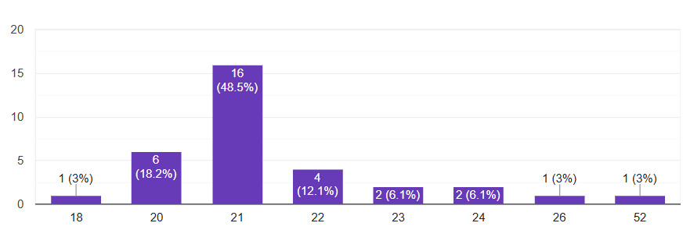
27 of the 33 respondents, a supermajority of the sample, stated that they were monthly online shoppers, meaning they would typically shop online only once a month. 3 respondents shopped weekly, 2 respondents shopped yearly, and only 1 respondent shopped daily. This implies that most of our sample prefer to shop online across sparse periods, rather than on frequent occasions.
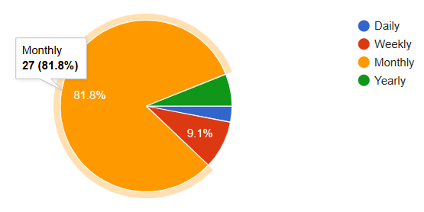
All 33 respondents indicated that they shop on their mobile phones, the most popular option by far. Only 9 respondents use their Personal Computers and only 2 use their tablets. This suggests that shoppers, at least among young adults, prefer to use mobile devices for their online shopping.
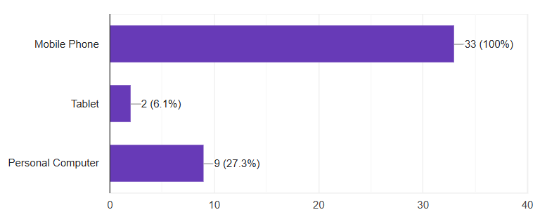
Of the 33 respondents, only 2 indicated that they reacted badly to a product they bought online. However, 10 respondents stated they knew 1 or 2 people who reacted badly to a product that person bought, and 3 people knew 3 to 5 people. Thus, 13 out of 33 respondents know someone who reacted badly to a product purchased online.
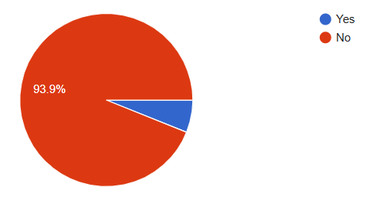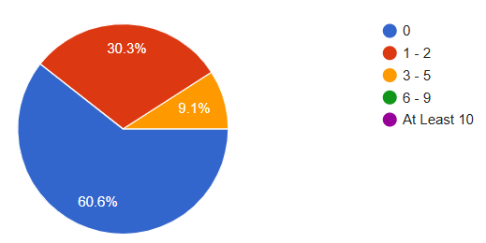
When asked what the first thing people noticed about a product they wanted to buy online, 17 of the 33 respondents, a majority of the sample, said that price is the first thing that catches their attention. Afterwards, was the Product’s Rating, then a tie between its Image and Number of Reviews, and then the number sold.
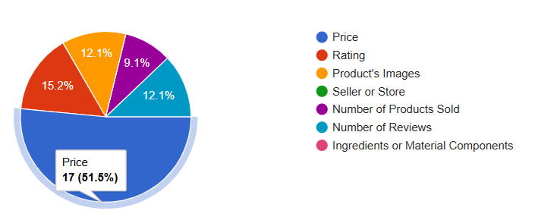
However, when asked which feature is the most important to consider before buying, the results are more mixed. The most popular choice was Rating, which 10 selected. Following was the product’s Number of Reviews, which 9 people selected, then by Price and Material Components. This is a peculiar finding, as it implies that there is a dissonance between what online shoppers first notice about something they want to buy and what they consider to be the most important factor when deliberating about whether or not to consider buying it.
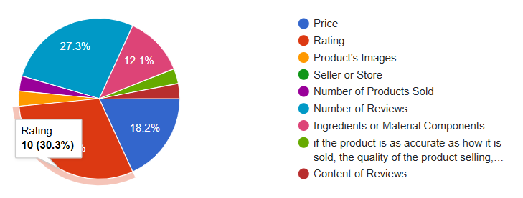
When asked what type of products they would normally buy, Accessories was the most common type, with 22 of the 33 respondents, a supermajority, indicating that they buy these types of products online. Following was Clothing with 20, Simple Devices with 16, Electronics with 14, Cosmetics and Self-Care with 13, Games with 12, and then Cleaning Agents with 10.
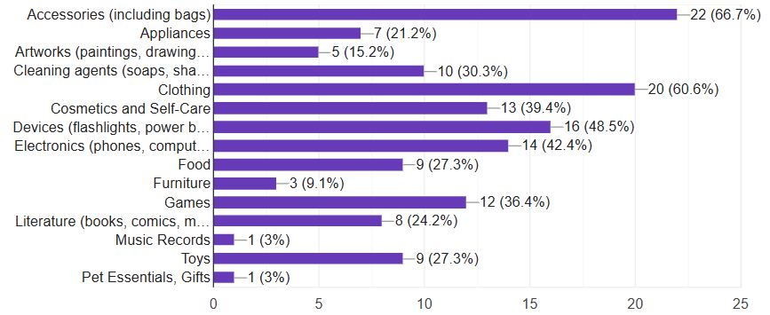
When asked to rate how much attention they give to the material components of the products while they shop online, 15 of the 33 respondents gave a 5 (A lot of attention to products’ components), 9 respondents gave 4, 3 respondents said 3, and only 2 respondents gave 2. No respondent gave a 1 or 0 (No attention to products’ components). These results indicate that all shoppers of the sample place a good deal of importance on what a product is made of, with most people considering it very important and no one considering it unimportant.
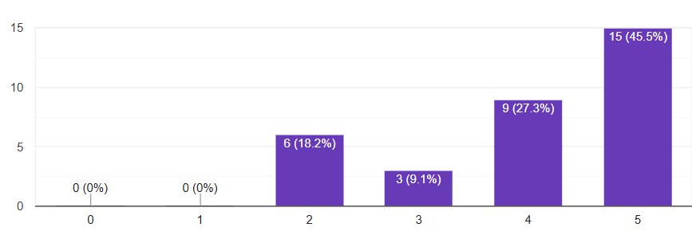

Models of Results
The following models are derived from the survey results and interviews conducted by the researchers. These models illustrate the cultural context of the participants, highlighting their expectations, desires, values, and the written and unwritten policies that influence their online shopping behavior. We have identified three distinct models representing different user personas based on their occupation and shopping intentions. Each model is structured around four key categories, which align with our research questions and provide a comprehensive view of the participants' shopping habits and preferences. These categories are:

- Material Preference - This category explores the types of products participants are primarily interested in and the importance they place on the quality and composition of these products.
- Risk and Safety Perception - This examines how participants assess the authenticity and safety of the products they purchase, including their awareness and consideration of potential risks associated with material composition.
- Device Preference - This category identifies the devices participants prefer to use for online shopping, considering factors such as convenience, accessibility, and functionality.
- Buyer Behavior - This analyzes the frequency of participants' online shopping activities, the features that most attract their attention to products, and the motivations behind their purchasing decisions.

The cultural models serve as a framework to understand the mindset within which the participants operate. It defines their expectations, desires, and values, and captures the various influences that affect and constrain their shopping behavior.

Customer
(University Student)

Device Preference
Material Preference
Risk and Safety Perception
Buyer Behavior
The majority of students online shop for accessories, clothing and devices like flashlights or power banks.
The average shopper pay more attention to the material composition of the product the more expensive the product is.
Mobile phones are used for online shopping based on convenience and location. There are also more vouchers available using mobile.

Some use other devices but it is usually dependent on their setup.
The average university student shops infrequently like once or twice a month. Mostly buying products when deemed necessary by the shopper.
Students tend to wait for sales or look for discounts before making a purchase.
The material composition determines the durability and quality of the product, so paying attention to it depends on what kind of product they are purchasing–whether they will use it long-term or just temporarily.
They believe that it’s important to be aware of the material composition, but it is not the sole deciding factor in making a purchase.
Frequent shopping platforms are Lazada and Shopee but there are other stores they visit like Zalora. For region convenience, there’s also Amazon. Tiktok shop is also a growing trend among younger shoppers.
The first thing they notice is the price of a product, but the most important factor they consider is the rating, followed by the number of reviews.
Model 1 - University Student
Customer
(Hobbyist)

Device Preference
Material Preference
Risk and Safety Perception
Buyer Behavior

Material Finish; Product Quality is important
Tied with material preference
Only buys through mobile device, specifically smartphone

Buys on dedicated, reputable e commerce application/s

Shopping experience must be convenient
Perceptive about anything off putting about a product
Product comments used to verify if the product is fake, potentially dangerous.

Shops during sales; At least one or twice a month
Price range: 200 - 300 pesos
When buying outside of sales: only buys necessities/other miscellaneous items not available within their area

Looks at ratings first

Model 2 - Hobbyist
Customer
(Student Intern)

Platform Preference
Material Preference
Risk and Safety Perception
Buyer Behavior
Preference is usually set according to the person’s employer’s needs
Risk and safety perception is mostly tied to company needs
A desktop is used to shop for increased performance, improved access to details, and better and more convenient organization capabilities.
Shopping is done on a daily basis for the employer.
The user primarily looked at price and would send the item to a supervisor for further analysis.
It does not seem additional risk and safety perceptions are in the person’s role. As such, these matters are left to a supervisor.

Important to get the specification right for employer’s needs
Shopping platform of choice is Amazon since it has faster transaction and deliveries and already has connections with employer
Model 3 - Student Intern

DISCUSSION

The data gathered on toxic materials found in the products produced, purchased, and consumed shows many different toxins both to the human body and to the general environment. Concentrations may vary and as such, the level of harm is inconsistent, potential build up of these materials may harm the body or the local environment if these potentially hazardous substances are not used and disposed of properly. For instance, 1,4 dioxane is known to be incredibly dangerous and affects the liver and kidneys but this danger manifests only when the body is exposed to high amounts of the material over a short time or if there is general exposure over a long time (CDC, 2015). These harmful substances are mostly controlled by governmental organizations like the FDA of the Philippines, as such, these harmful substances are mostly kept under control. Instead of warning users about the dangers of these substances, it would be more productive to inform consumers about responsible handling of products with these substances. For instance, proper disposal of cosmetic products would significantly reduce any potential harm they might do to the environment.

The results gathered through the survey and interviews allows us to infer that people generally do not focus on the materials that make up the products they purchase from e-commerce platforms. The participants, mostly university students, seem to purchase mostly consumer products that are inorganic and are usually harmful when not properly disposed of. A limitation of the study on this matter is a lack of further inquiry on the matter of how aware users are of the implications of how they handle products with potentially hazardous materials. This can be further looked into during the prototyping phase, more specifically when testing the prototype the researchers can look into the reactions of users to how they might be made more aware of potentially hazardous materials and how to handle them properly. In addition to these realizations, the researchers made notes on where the behaviors of the users are when they are shopping for products on these e-commerce platforms. More specifically, what users pay attention to, what platforms they use, their reasons for these choices and behaviors. These aspects will allow the researchers to work on a potential solution for the design problem while ensuring that these solutions remain convenient and non-obtrusive

Focused Design Problem:
Users on E-commerce platforms need to be made more aware and knowledgeable about how to responsibly handle products with potentially hazardous materials that they purchase as it would result in less health hazards, damage to the environment, and also a better experience with the products.

REFERENCES
- New York Health Foundation. (n.d.). Fact sheet. https://nyhealthfoundation.org/wp-content/uploads/2023/05/potentially-toxic-chemicals-personal-care-products.pdf
- National Geographic. (n.d.). Microplastics. Education. https://education.nationalgeographic.org/resource/microplastics/
- Yulan, Z., Shichang, K., Steve, A., Deonie, A., Tanguang, G., & Mika, S. (2020, February 10). Atmospheric microplastics: A review on current status and Perspectives. Earth-Science Reviews. https://www.sciencedirect.com/science/article/pii/S001282521930621X
- US Department of Commerce, N. O. and A. A. (2016, April 13). What are microplastics?. NOAA’s National Ocean Service. https://oceanservice.noaa.gov/facts/microplastics.html
- Pinto-Rodrigues, A. (2023, April 10). Microplastics are in our bodies. here’s why we don’t know the Health Risks. Science News. https://www.sciencenews.org/article/microplastics-human-bodies-health-risks
- Quiancheng, Z., Long, Z., Jiaming, W., Zirun, J., Yalei, C., Hui, J., & Zhe, Z. (2023, March 21). Detection and characterization of microplastics in the human testis and semen. Science of The Total Environment. https://www.sciencedirect.com/science/article/abs/pii/S0048969723013293
- Admin. (2021, October 30). 7 types of plastic that are most common. Plastic Oceans International. https://plasticoceans.org/7-types-of-plastic/
- CDC. (2015, June 18). 1,4-Dioxane | Public Health Statement | ATSDR. Agency for Toxic Substances and Disease Registry. Retrieved June 25, 2024, from https://wwwn.cdc.gov/TSP/PHS/PHS.aspx?phsid=953&toxid=199#

SURVEY LINK:
Survey: Buying habits and product cautiousness of online shoppers (google.com)
Results: STHCIUX Survey - Google Forms

